SpaceJoist Design Information Request
Client guide

The purpose of this Document is to identify to the Building Designer the Critical Information required to complete a SpaceJoist Floor Design.
Table of Contents
Floor Features and Recommended Drawings 2
Recommended Section Drawings 3
Support Details. 4
Aperture Details 5
Building Designer Responsibility 6

Floor Features and Recommended Drawings
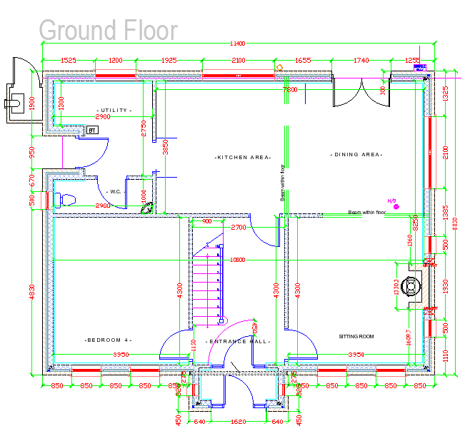
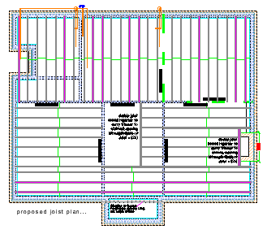
Dimensioned Floor Plans
SpaceJoists are designed to suit exact setting out.
As such, floor plans must be provided with all dimensions for both external and internal walls.
Any discrepancies during construction may mean that the SpaceJoists will not fit and may require re-designing.
Load bearing walls must be highlighted on plans.

It is important to remember that any connection of the floor structure to the building must be reviewed and confirmed by the building designer.

SpaceJoist Span
The designer must be told if the project engineer requires joists to span in a certain direction. Also, if joists are required to be at predetermined centers.
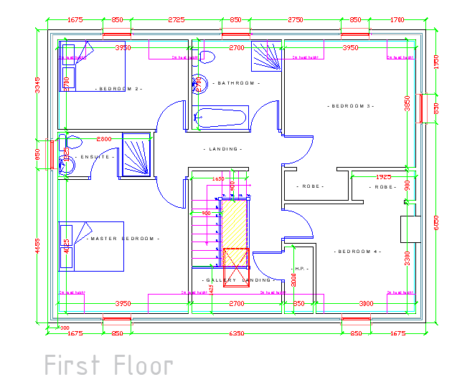
The provision of a proposed joist layout helps the designer to fulfill these requirements.
Accurate dimensions of walls will ensure
the designer can produce SpaceJoists
with correct spans.
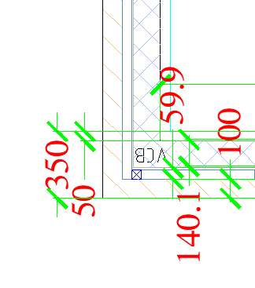

Recommended Section Drawings

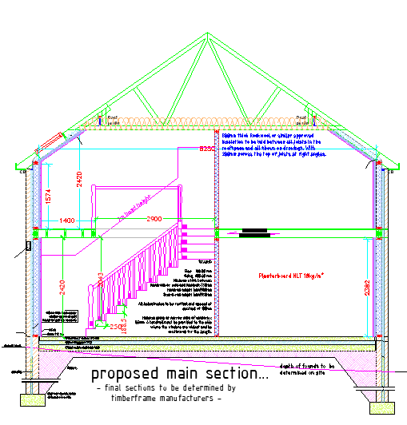
Sections showing dimensions for stairs is recommended as this provides the designer with accurate information to allow for stair opening.

Accurate dimensions will ensure the correct ope is allowed for Stairs .
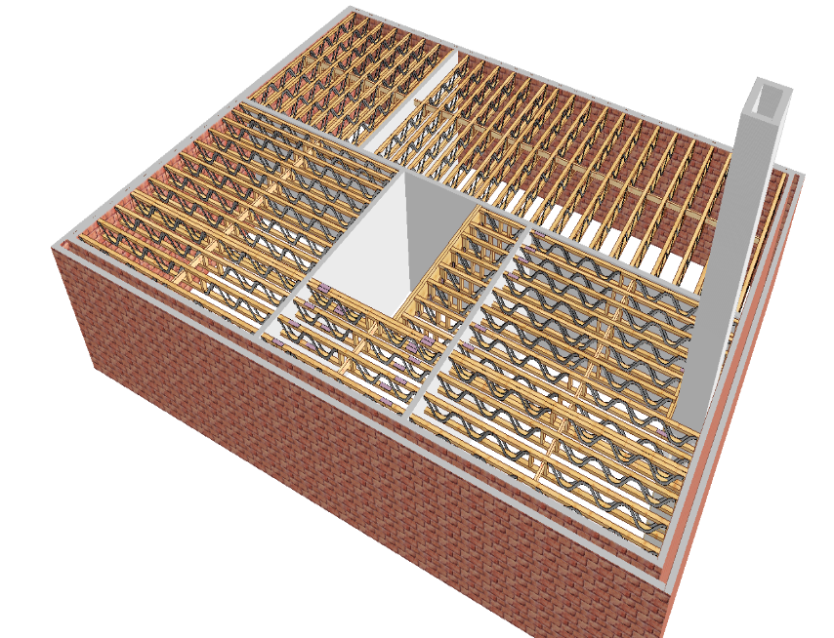
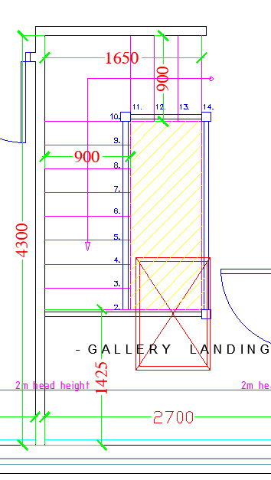

Support Details.
Details should be provided as to how the SpaceJoists are intended to be supported. Details shown below are the most common- for more details and information please see the SpaceJoist technical guide- available to download at www.itwcp-offsite.co.uk
Masonry
SD1- Build-in to Masonry SD2-Hanger Support onto Masonry
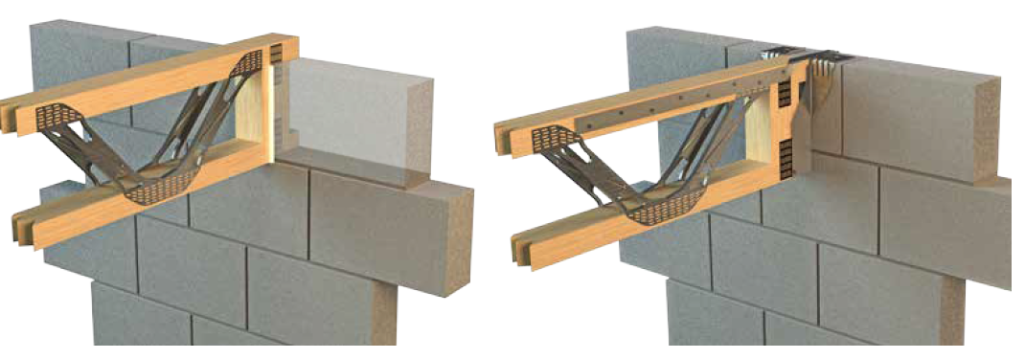

Steel Beam

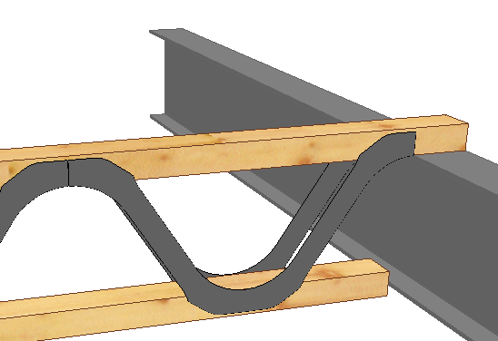
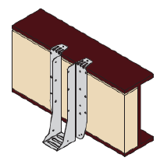
Beam Filled with Timber and SpaceJoist Top Chord Supported SpaceJoist on
supported by Hanger. Steel Beam.

Aperture Details
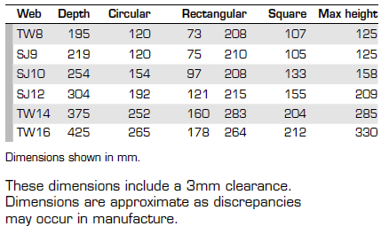
It is important for a designer to be aware of the max size of ducts that are in the SpaceJoist zone.
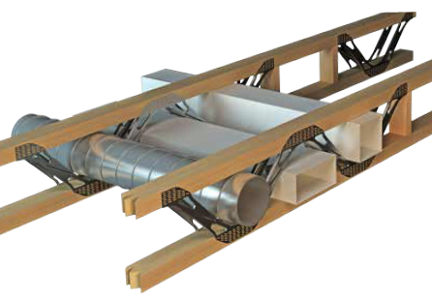

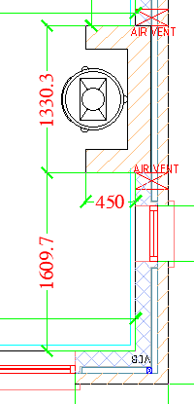
Ground Floor Chimney First Floor Chimney
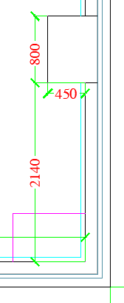
Chimney dimensioning is very important as we can see from the sections that the chimney can reduce in size as it progresses from ground floor to first floor. This enables the correct opening and spacing of SpaceJoists and improves floor designs.
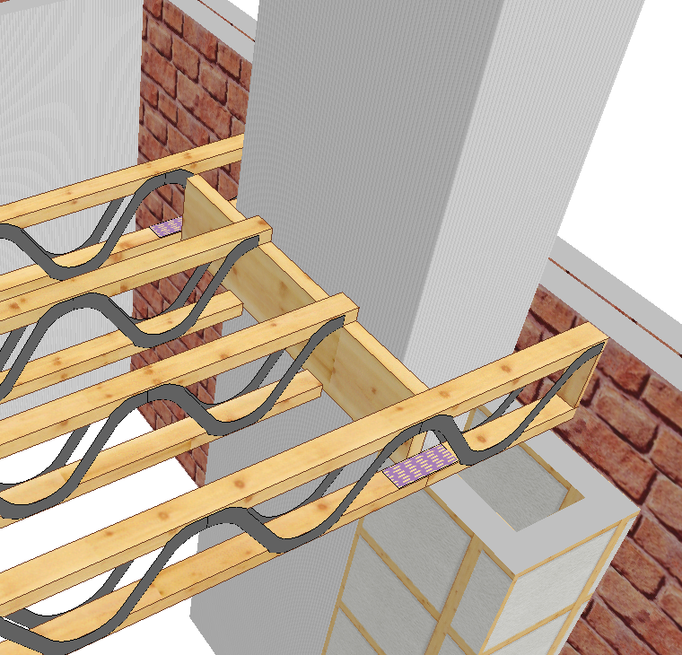

Building Designer Responsibility

Building restraint & bracing

The floor designer takes responsibility for the bracing of the floor structure, however, the bracing of the building and therefore the connection of the floor bracing to the structure is the responsibility of the building designer.
Loadings

It is the building designer’s responsibility to inform the floor designer of all the loads being applied to the floor structure. The building designer should review the design to ensure the SpaceJoist designer has accounted for all necessary loadings.

Connection of timber structure to building

Specifications of connections of the floor structure to the building are the responsibility of the building designer, these must be reviewed during approval to ensure they meet requirements. Building designers should particularly ensure that actions of wind onto a building have been taken into consideration.

