Timber roof trusses at Visitors Centre

Cork Roof Truss Company Ltd supplied a timber trussed rafter roof complete with wind girders and necessary concrete fixings for the Visitor Centre at the new Cork Prison – part of a €42m project to replace the Victorian prison facilities in the area. Originally designed as a steel portal roof, contractors PJ Hegarty were keen to investigate the use of timber, being a renewable resource, as an alternative.

The irregularly pitched, rectangular hipped roof supported on prefabricated concrete walls comprised of 277 trusses (some with max overall spans exceeding 18 metres) and 107 infill pieces. The timber structure was designed and detailed using the GN Roof and Truss software.

Due to the prefabricated concrete walls’ limited fixity at their base, wind girders were required to form part of the roof structure to provide lateral restraint at wall plate level. The girders were fastened with some 300 Tapcon II concrete screws and chemical anchors also supplied by ITW Construction Products.

ITW Construction Product’s expertise was called upon for both the design of the trusses & wind girders by the Gang-Nail technical support team and for the fastening of the girders to concrete walls by their SPIT fixing experts.

Brian Humphries, Cork Roof Truss Company’s Managing Director commented – “These are the largest roof trusses we have made and presented their own unique set of problems from a manufacturing and transport perspective. Whilst we were concentrating on resolving these issues, the Gang-Nail office liaised closely with Punch Consulting, the consulting engineers, in order to resolve the technical queries as they arose.”

Paul Baron of the Gang-Nail team explained – “The length of the wind girders meant they required fixing to intermediate masonry walls. The problem we had to overcome was to place sufficient anchors to resist the horizontal forces within a fairly small area whilst maintaining the minimum bolt spacing requirements for both timber and masonry. We did this by using larger diameter anchors for which there was no test data for the particular density of block used on site. We extrapolated test data from similar smaller diameter fixings and agreed values with the consulting engineer.”

The superseded prison was originally built by the British army as barracks in 1806 – which included military detention barracks. Following proclamation of the Irish Republic, in 1922 the building was handed over to the Irish military who maintained its use as a barracks. In 1972 the detention barracks was transferred to the Irish Department of Justice for use a civilian prison.

Construction of this new medium security prison began in Feb 2014 and opened fully in February 2016. The modern facility holds up to 275 adult male prisoners in better conditions, with energy costs estimated to be 85% of the old prison.

For further information on Cork Roof Truss Ltd, visit their website at www.crtc.ie. ITW Construction Products welcome enquiries on their truss and fastening systems – contact their customer service team on 01592 771132 or visit www.itwcp.com.

# # #

Pictures:

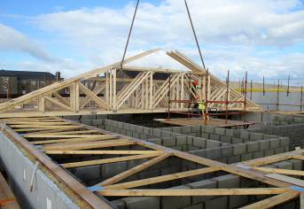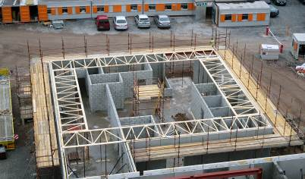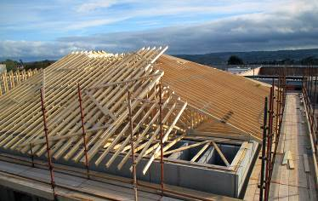
PR 0148-01 PR 0148-02 PR 0148-03

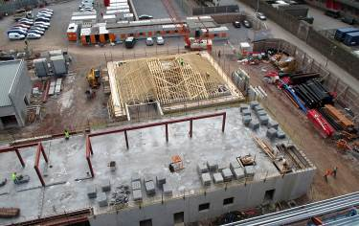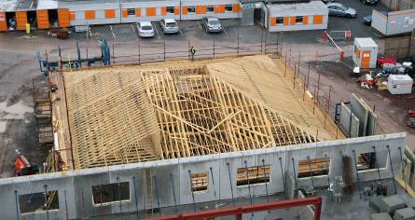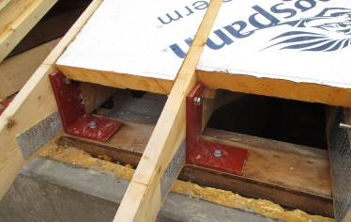
PR 0148-04 PR 0148-05 PR 0148-06

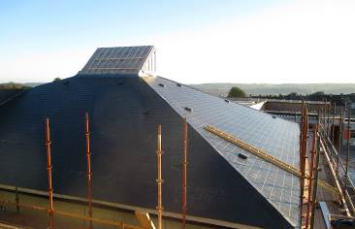
PR 0148-07

